Draft dissertation paper

Introduction
Context for the project
- Social media is a primary space for political discussion. Also facilitates the large-scale spread of misinformation and malicious content.
- The harm posed by false online content is significantly exacerbated by the extent of its spread. Without sufficient moderation and enforcement of community guidelines, widespread diffusion of this content is possible. On the largest scales, what began as an extreme, contained opinion can evolve to a mass belief in society.
Motivation for work
- 2024 UK riots – false claims about the attacker’s identity spread across social media platforms, amplified by influencers and foreign actors. Violence that followed was the direct consequence of the spread of this misinformation online (Munk and Ahmad, 2026)
- It is directly in the public interest to understand what makes political social media content spread, and specifically to what extent the veracity of content plays a role in virality
- The dominant studies on misinformation virality are heavily US and Twitter-centric (Grinberg et al., 2019; Vosoughi et al., 2018). There is a research gap (no other papers to my knowledge) on the virality of UK political discourse on social media, specifically Reddit. Credible fake news benchmarks (Fakeddit, FakeNewNet) are also US-focussed (Nakamura et al., 2020; Shu et al., 2020). Also, veracity is typically treated as a target, rather than a feature within a virality model. The relationship between virality and veracity is a subject that recent work has begun to address (Esteban-Bravo et al., 2024; Savatteri et al., 2026), providing motivation to apply this to a UK political Reddit context.
- Why Reddit (vs X or Facebook)?
  - Reddit is a discussion oriented online social network, split into subreddits (topic-specific communities) where users can post and comment, having their own rules and moderators. Large user base (126.8 million daily active users, reference) makes it an ideal platform for studying online discussion
  - Differing behaviour between subreddits means virality should be measured relative to a community (motivation for size-normalised virality target)
  - Ranking mechanism is vote-based and easily interpretable, not an opaque algorithm like X. Documented ‘hot’ ranking combines net votes with time decay
  - Lower barrier to obtaining data than other platforms – archives available with post-level engagement metadata
  - Under-studied domain relative to other popular social media platforms like X
- Why UK Politics in 2024
  - The UK has a distinct political and social media ecosystem from the US centric literature – likely to observe different virality mechanisms
  - 2024 particularly important year for UK political discourse – general election, summer riots). Likely to provide a dataset with a high concentration of discussion around significant political events. (Antypas et al., 2026; Munk and Ahmad, 2026)
  - Though misinformation about the riots was primarily propagated on X/Facebook/Telegram, they provide the societal motivation to investigate misinformation/virality mechanisms.
This project seeks to build a transferable and explainable virality prediction pipeline for UK, political Reddit posts. SHAP will be used to investigate how features interact with virality in a unimodal, textual corpus, with a specific focus on ascertaining whether veracity is a meaning predictor of virality . Seeks to answers the following:
- RQ1: Which of structural, linguistic, emotional, political-leaning, topic and veracity features predict virality on UK political Reddit?
- RQ2: Is veracity (true vs fake) a meaningful predictor of virality, and in which direction?
- RQ3: If veracity is a meaningful predictor, do viral true and viral fake posts go viral for the same reasons? (Esteban-Bravo et al., 2024)
Related work
Virality prediction on social media
- (Barnes et al., 2021) – constructs a virality metric from post metadata and predicts meme virality on Reddit from the engineering of features derived from text, image, and post metadata. Multimodal dataset derived from general meme subreddits, so context of posts differs. Tree-based models were used to make predictions, with a best AUC of 0.68. Notes the added value of image features over textual.
- (Dogan et al., 2026) go a step further than static, volume-based thresholds, putting forward a virality definition that integrates dynamic features like post velocity and acceleration. With a 5% viral class, their multimodal XGBoost classifier achieve a PR AUC of 0.80 for posts online for 420 minutes. They also report a content ceiling, where structural and temporal features are required to surpass content-only baselines.
- (Lynch and Livan, 2026) – predicts discussion initiation and thread size on Reddit, including r/USPolitics, proposing it as Pipeline is LightGBM followed by SHAP on textual/emporal/domain/author features, finding that the top predictors of engagement are author posting frequency and domain authority. Careful feature selection led to a concise, interpretable feature set that captured the majority of the signal. Though methodologically rich for Reddit virality research, the work does not consider post veracity or the UK political context, and predicts a different engagement metric.
- (Chauhan et al., 2025) also make use of dynamic diffusion features, investigating the role of both textual and visual content in virality across ideologically diverse subreddits. Make use of BERT textual embeddings, VADER sentiment scores and SHAP for feature importance. K
UK political Reddit – some research but not on virality
- (Antypas et al., 2024) – large corpus of UK political Reddit, finds that a curated set of domain-specific trigger words (‘Brexit’, ‘NHS’, ‘immigration’) is associated with higher engagement and contentiousness. Very specific features, doesn’t consider post veracity or virality as a metric.
- (Rizoiu et al., 2026) – UK political reddit (r/Brexit) but the task is measuring and analysing polarisation dynamics over Brexit periods (2015-2021).
Misinformation/fake-news, emotion and diffusion
- (Rathje and Van Bavel, 2025) – discussion of why content goes viral, introducing the ‘paradox of virality’ – widely shared content is often not widely liked. Explain how ‘psychological processes behind virality interact with structural features of information environments’. Insight into why certain features in a dataset may drive virality.
- Fake news and virality interplay – paper discussing how fake news spreads faster and further than authentic (Vosoughi et al., 2018)
- Research focussing not just on the detection, but on the diffusion of fake news. (Savatteri et al., 2026) compare these two tasks, while subgroup analysis from (Esteban-Bravo et al., 2024) show that content features affect virality differently for true and fake news. This motivates RQ3 on virality/veracity subgroup analysis.
- (Antypas et al., 2023) find, using a Twitter corpus, that negative negativity is retweeted. Same group (Antypas et al., 2026) find that trigger words causally increase engagement and animosity on UK political reddit
- more. (Zhang et al., 2021) – extract emotion as a feature for fake news detection. Motivates use of sentiment/emotion scores as features in the virality predictor.
Fake news detection and dataset
- Fakeddit (Nakamura et al., 2020) – US focussed, multimodal, large Reddit fake news dataset, labelled for fake news using 2, 3 and 6-way taxonomy. FakeNewsNet labelled fake news benchmark, but consists of news articles, not social media focussed,
- Current standard for text-based detection of fake news is to use fine-tuned transformers (Mouratidis et al., 2025)
- No UK-specific, labelled fake news corpus of Reddit posts. (Ratner et al., 2017) – weak supervision framework for labelling of large datasets. Potential route for engineering a veracity feature, given no dataset exists in the problem space.
Political leaning
- Source bias from MediaBiasFactCheck (Sanchez-Cortes et al., 2024) has been used as a foundation for research on how news, bias, and factualness spread across the internet (Weld et al., 2021). Domain credibility used as a feature in a Reddit context
- Zero-shot stance extraction from Reddit text (Togay et al., 2026). Political stance extraction for a Reddit dataset is possible, but requires leveraging LLMs

Explainable ML for misinformation
- SHAP (Lundberg and Lee, 2017), TreeSHAP (Lundberg et al., 2019) for tree models – standard explainability tool for fake news detection (Gongane et al., 2024) (RF/gradient boosted misinformation models (Mouratidis et al., 2025)). Also utilised in previously mentioned virality papers e.g. (Lynch and Livan, 2026)
Summary and research gap
- Virality has been investigated from many angles, detailed above, but none appear to have covered the exact intersection of this research topic
  - Virality prediction on Reddit has been almost entirely removed from the context of UK politics. Barnes et al. (2021) and Dogan et al. (2026); Chauhan et al. (2025) – meme or cross-community virality. Lynch and Livan (2026) – closest to my virality context but US focussed, predicting thread size. Justification for tree model and SHAP virality pipeline but don’t target UK political discourse.
  - Existing work on UK political Reddit does not cover virality (see subsection above)
  - Treating misinfo as a virality feature in the UK political reddit domain has not been investigated.
Methodology
Requirements capture / analysis – what your system should do
- Main aim - given a Reddit post’s content and metadata, predict whether it will go viral within its community and explain which features contribute most to that prediction
- Functional requirements
  - Ingest Reddit data (Fakeddit US, Pushift UK) and produce a clean feature set with post-level granularity
  - Define a statistically sound, community-normalised virality arget
  - Determine whether veracity is a meaningful contributor to virality by running the prediction pipeline on the US Fakeddit dataset, where ground-truth true/fake content labels are available.
  - If deemed an important feature, obtain a true/fake veracity signal for unlabelled UK data
  - Train and evaluate tree-based virality estimation models. Report performance metrics appropriate for class imbalance (PR AUC, macro F1, MCC), use confidence intervals.
  - Investigate feature importance using SHAP,
Design – how you went about your work
- Virality pipeline on Fakeddit (US) to establish importance of binary fake feature relative to structural/textual features. Dataset selected for ground truth veracity labels.SHAP to assess feature importance.
- Conditional on step 1 – train a BERT model on US Fakeddit. Establish whether US-UK corpora have sufficient overlap in semantic/lexical/engagement distributions to justify domain shift of veracity classifier. Generate a veracity proxy for the unlabelled UK data.
- Train and evaluate UK virality estimator, analysis of veracity-virality relationship (if veracity proxy included), investigation into feature importance with SHAP.
Datasets
- US Fakeddit – for assessing importance of true/fake label as a virality feature
  - Multimodal only subset (the version used in their model benchmarking, better data quality).
  - 564k train / 59k val / 59k test (provided splits)
  - Flag – this is a US-centred, image heavy dataset that may have very different virality behaviour to UK political (modality and domain shift), text-only posts.
- UK Pushift (Baumgartner et al., 2020)
  - Reddit submissions from the Pushift archive. Chosen because Pushift API restrictions post 2023 make using it for data collection infeasible
  - All months of 2024 ingested – retained fields: id, created_utc, subreddit, title, selftext, score, num_comments, url
  - Filtered for UK specifc political and general subreddits. In train_df (80416 rows). Subreddit choice – general UK and UK politics subreddits, as well as party-specific and some topic specifc (policeuk, Brexit). Unitedkingdom dominates – keep?
unitedkingdom 41194
ukpolitics 20384
LabourUK 6590
policeuk 6085
uknews 3377
tories 1117
reformuk 860
brexit 619
BritishPolitics 142
gbnews 38
GreenPartyUK 10
- Dataset split – no predefined split, so constructed. Random split, stratified by subreddit. 80/10/10 train/val/test. Switch to chronological as done by (Lynch and Livan, 2026)

Implementation – practical techniques, problems, solutions
- Virality target construction – adapted from (Barnes et al., 2021)
  - Based off raw engagement = score + num_comments
  - Barnes et al. and Dogan et al. account for role of subreddit size in raw engagement score by normalising (divide each score by the subscriber count of the post’s subreddit). No subscriber counts available, use a proxy. Log transform the score (long-tailed distribution towards more normal justified using z-score) then compute a within subreddit z-score.
  - Virality threshold – top 10% of normalised engagement scores, evaluated on training set only and same absolute threshold applied to val/test – prevents leakage. Z = 1.55
  - Dogan et al. use a data-driven approach to the threshold: k-means (k=2), result is roughly top 5% virality class. Rejected in this case as the data distribution was unimodal – no clear split for clusters

- Feature engineering – enrich dataset to allow for discussions of features contributing to virality
  - Structural/temporal (mirroring Barnes et al.): title word count; hour-of-day (4h bins), day-of-week, is_weekend (US Central / GMT); has_image (native Fakeddit; engineered from URL for UK); caps ratio; punctuation densities (?, !, repeated) normalised by length (UK; stylometric, kept separate from VADER for explainability. Will add justification for these features
  - Domain bias and credibility (mapped from MBFC (Sanchez-Cortes et al., 2024). Label encoded – ordinal. Sparsity is an issue – around 92% of domains are reddit native or unrated by MBFC.
  - Pyscholinguistic: EmoLex 8 emotions (ref) and VADER compound score (overall pos/neg sentiment – ref). Only looking at the emotion of the post so far, not the comments – limitation. Emolex contet blind, lexical only – limitation.
  - PLANNED:
    - (Lynch and Livan, 2026) found author activity and domain authority/frequency to be dense, important features in their SHAP analysis. Add to hopefully capture more of virality signal and strengthen feature set.
    - Political leaning – yet to find a suitable model that will be credible for extracting the feature for 2024 reddit.
    - Veracity – ground truth for US, but potentially generated using weak supervision/US-trained BERT for UK.
  - ADD – feature correlation matrix, feature sparsity plot
- Models and evaluation
  - Framework: XGBoost Classifier cross-validated against a baseline Random Forest Classifier (Barnes et al., 2020; Dogan et al., 2026).
  - Metrics: Model optimization targets PR-AUC and Macro-F1 to correctly evaluate performance against class-imbalanced data (Dogan et al., 2026).
  - May use grid search to tune model hyperparameters but have just run baselines for now

Results
US Fakeddit virality pipeline
1. Virality target
- Raw engagement = score + num_comments, log transformed then within-subreddit z-scored
- Threshold at top 10% of normalised engagement on training set only (z = 1.36, approx 252 raw engagement). Viral class = 10.2%
- K means (k=2) rejected because the distribution was unimodal - would have set the viral bar at around 55 raw engagement, too low

2. Model performance
- Balanced Random Forest: ROC-AUC 0.616, PR-AUC 0.149, Macro-F1 0.334 (threshold 0.422)
- XGBoost (scale_pos_weight 8.99): ROC-AUC 0.609, PR-AUC 0.148, Macro-F1 0.280 (threshold 0.378)
- Both models perform badly. Potentially a dataset characteristic rather than a model failure - Fakeddit is image driven so textual and metadata features have minimal signal for predicting engagement
- 23 features, class balance 90/10

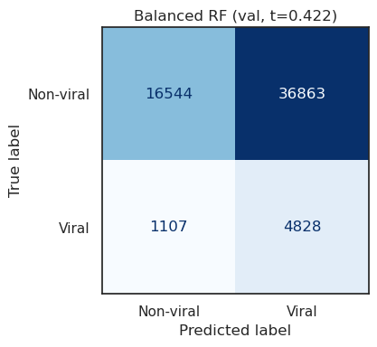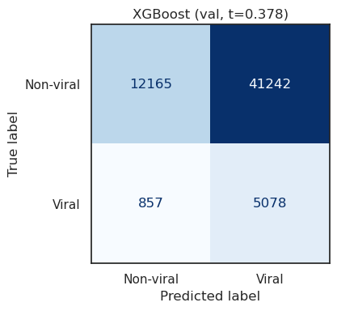
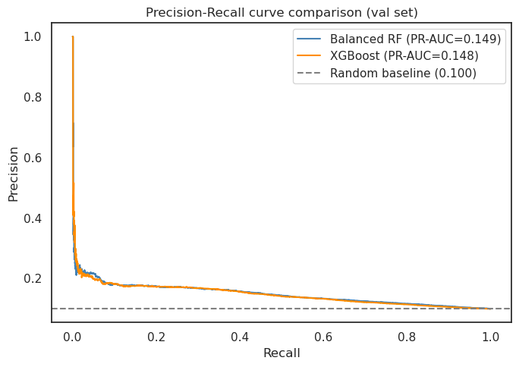
- Feature importance (global SHAP)
- time_of_day dominant by a large margin (mean SHAP 0.325). Consistent with Barnes et al (2020)
- is_fake second (0.127). Strongest content-based signal despite weak model performance
- title_word_count third (0.076). Small but consistent with Tsur and Rappoport (2012), brevity = higher popularity
- Emotion features weak. Expected given the stat significance test results in the feature analysis
- MBFC credibility features negligible. Expected due to 92% sparsity (majority of domains are reddit native)
- hasImage and is_weekend have 0 importance - error in weekend calc and every fakeddit post has an image so it is redundant.
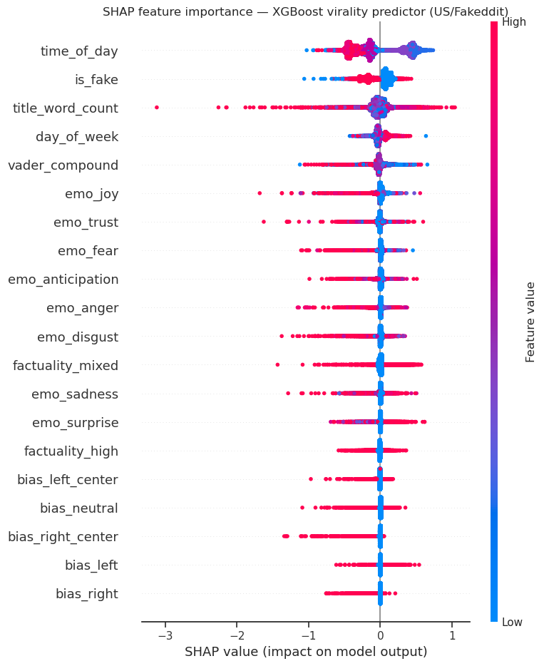
- Directionality of is_fake
  - Fake content pushes away from virality (mean SHAP -0.168 for fake vs +0.091 for true)
  - Suggests true content is more likely to go viral than fake content in the Fakeddit dataset
  - SHAP dependence plot: true posts cluster above 0 (around 0.2-0.25), fake below (-0.4 to -0.5). Suppression on fake greater than boost for true. A small number of fake posts have positive SHAP but overall direction is clearly negative
  - Why? The image-centric content of Fakeddit (image manipulation, propaganda posters, satire) likely engaged with differently to political misinformation. Virality mechanism for general US meme content may differ from political misinfo. UK analysis on text-only political reddits will help investigate this
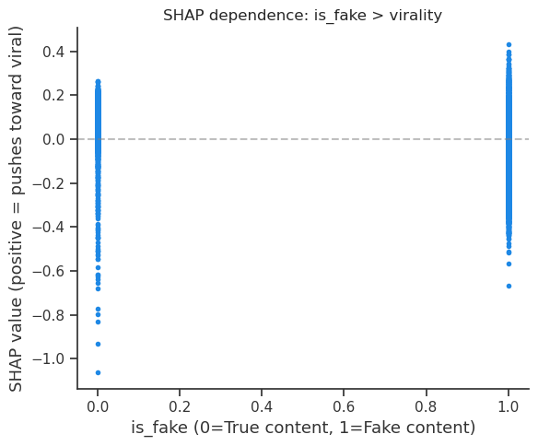
- Sufficient to establish that fake content is an important factor?
UK political reddit virality pipeline
- Virality target
- Same construction as before
- Two spikes in the normalised z-distribution (z around -0.75 and -0.5) coming from the mass of posts with raw engagement around 1
- 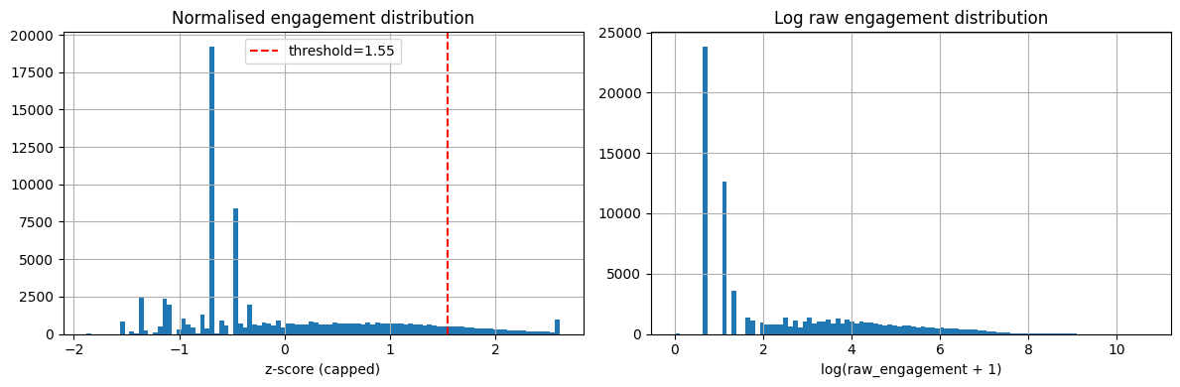
- Features (pre modelling)
Domain:
- Big difference in virality rate between external and native domains: 15% external vs 3% native (+11.3%)
- Polarised domains dominate engagement - right centre and right wing (1 and 2) outperform neutral (0)
- Mixed factuality (2) domains consistently outperform high factuality

Emotion (viral vs non-viral)
- Viral posts have a significantly more negative VADER sentiment score (-0.150 vs -0.037)
- Anger, disgust and fear significantly increase for viral posts (around +30%)
- Viral posts have a higher mean absolute intensity score

- Models
- Balanced Random Forest: ROC-AUC 0.734, PR-AUC 0.226, Macro-F1 0.447
- XGBoost (scale_pos_weight 9.0): ROC-AUC 0.734, PR-AUC 0.231
- Best Macro-F1 around 0.57 (RF at threshold 0.5)
- Better separated than the US model (PR-AUC 0.23 vs 0.15) - UK political text carries more engagement signal than US memes
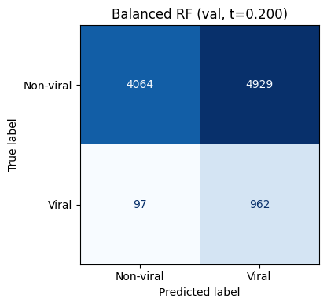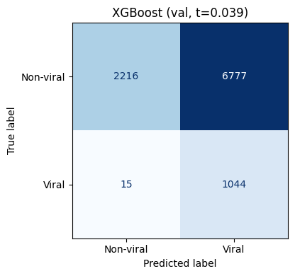
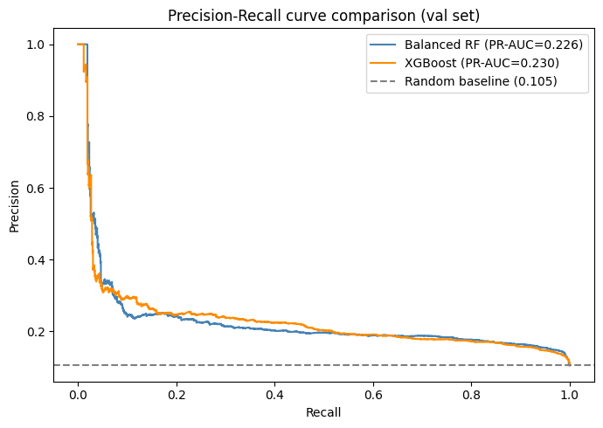
- Feature importance – global sHAP
- is_external_link most important (0.743) - news links vs native discussion
- word_count second (0.721) - brevity effect again
- caps_ratio third (0.400) - likely suppresses (spam/clickbait downvoted or removed)
- vader_compound (0.182) - positive sentiment pushes towards viral (counterintuitive vs misinfo literature, likely confounded with external news links)
- has_image (0.178), time_of_day (0.169), q_density (0.148, suppresses)
- MBFC factuality (0.092) and emotion features weak/mid, bias spectrum low
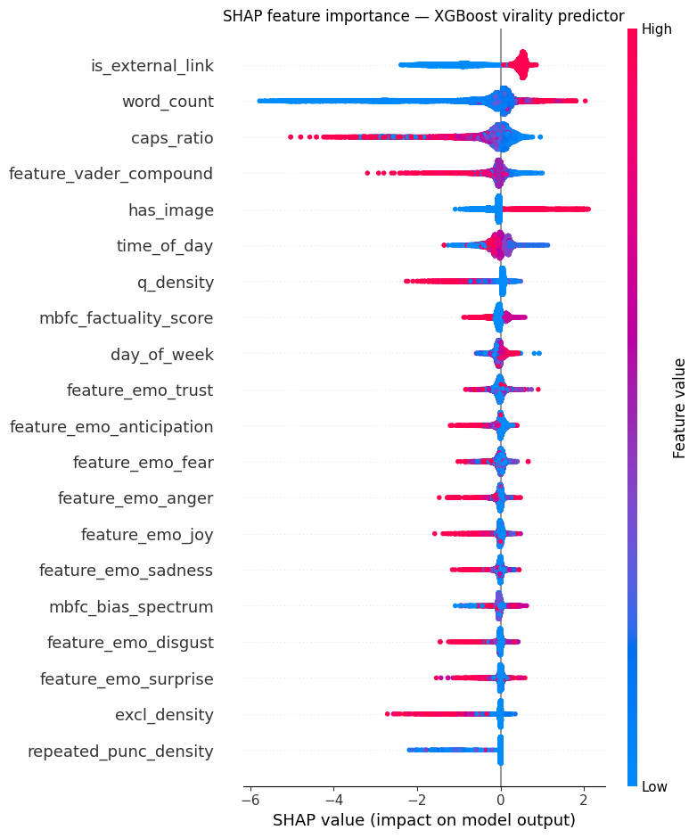
BERT fakeddit classifier
- Binary Fakeddit label: true vs fake
- bert-base-uncased, fine-tuned end to end
- 0.1 warmup ratio, 0.01 weight decay as recommended in BERT literature
- Include MCC - classes are imbalanced. It accounts for all four quadrants of the confusion matrix, only scores highly if good across all groups
- Grid search on subsample then retrained with best configs - batch 32, lr 3e-5, best at epoch 2 (val macro-F1 0.866)
- Test set perAccuracy 0.895, macro-F1 0.890, MCC 0.793. Fakeddit benchmark acc 0.82

NOTES/TO DO
- Attempt to add the p_fake veracity proxy to the UK model? Transfer the US-trained BERT, use weak supervision, or find a post-level political dataset. In both cases, would need hand-label a small set to check it actually works on UK text
- Add author activity and domain authority/frequency features (Lynch and Livan)
- Political leaning feature - still haven't found a leaning model that's credible for 2023/24 Reddi
- Run BERTopic on the UK train set, then split the SHAP results by topic. Check whether viral rates and the p_fake effect differ by topic

- Report confidence intervals on PR-AUC and ROC-AUC. RF and XGBoost look identical (US 0.149 vs 0.148, UK 0.226 vs 0.231) - can't say if difference is real or noise without CIs. Bootstrap
- Put effect sizes on the emotion group differences. My sample is large so everything comes back "significant" - the p value is meaningless on its own. Need Mann-Whitney with rank-biserial so I can say how big the difference is, not just that one exists
- Check feature correlations before trusting the SHAP ranking. caps, punctuation and emotion features are probably correlated, and this is likely why the univariate emotion result (viral = more negative) contradicts the SHAP result (positive VADER = viral). Prune correlated features and see what happens
- More rigorous defence for 10% virality threshol
- Add feature sparsity and Spearman correlation plots. Backs up the claim that MBFC is too sparse to be useful (92% unrated)

Discussion / conclusions
- Critical analysis
- Honest appraisal
Future work
- How could you extend the work?

References
Antypas, D., Arnold, C., Ousidhoum, N., Almendros, C.P., Camacho-Collados, J., 2026. Causal Effects of Trigger Words in Social Media Discussions: A Large-Scale Case Study about UK Politics on Reddit, in: Proceedings of the 18th ACM Web Science Conference 2026. pp. 359–369. https://doi.org/10.1145/3795766.3799750
Antypas, D., Preece, A., Camacho-Collados, J., 2023. Negativity spreads faster: A large-scale multilingual twitter analysis on the role of sentiment in political communication. Online Soc. Netw. Media 33, 100242. https://doi.org/10.1016/j.osnem.2023.100242
Barnes, K., Riesenmy, T., Trinh, M.D., Lleshi, E., Balogh, N., Molontay, R., 2021. Dank or not? Analyzing and predicting the popularity of memes on Reddit. Appl. Netw. Sci. 6, 21. https://doi.org/10.1007/s41109-021-00358-7
Baumgartner, J., Zannettou, S., Keegan, B., Squire, M., Blackburn, J., 2020. The Pushshift Reddit Dataset. Proc. Int. AAAI Conf. Web Soc. Media 14, 830–839. https://doi.org/10.1609/icwsm.v14i1.7347
Chauhan, S., Hong, M., Vazhaeparambil, M., 2025. When GenAI Meets Fake News: Understanding Image Cascade Dynamics on Reddit. https://doi.org/10.48550/arXiv.2512.04639
Dogan, S., Dethlefs, N., Chakraborty, D., 2026. Early Multimodal Prediction of Cross-Lingual Meme Virality on Reddit: A Time-Window Analysis. https://doi.org/10.48550/arXiv.2510.05761
Esteban-Bravo, M., Jiménez-Rubido, L.D.L.M., Vidal-Sanz, J.M., 2024. Predicting the virality of fake news at the early stage of dissemination. Expert Syst. Appl. 248, 123390. https://doi.org/10.1016/j.eswa.2024.123390
Gongane, V.U., Munot, M.V., Anuse, A.D., 2024. A survey of explainable AI techniques for detection of fake news and hate speech on social media platforms. J. Comput. Soc. Sci. 7, 587–623. https://doi.org/10.1007/s42001-024-00248-9
Grinberg, N., Joseph, K., Friedland, L., Swire-Thompson, B., Lazer, D., 2019. Fake news on Twitter during the 2016 U.S. presidential election. Science 363, 374–378. https://doi.org/10.1126/science.aau2706
Lundberg, S.M., Erion, G., Chen, H., DeGrave, A., Prutkin, J.M., Nair, B., Katz, R., Himmelfarb, J., Bansal, N., Lee, S.-I., 2019. Explainable AI for Trees: From Local Explanations to Global Understanding. https://doi.org/10.48550/arXiv.1905.04610
Lundberg, S.M., Lee, S.-I., 2017. A Unified Approach to Interpreting Model Predictions, in: Advances in Neural Information Processing Systems. Curran Associates, Inc.
Lynch, C., Livan, G., 2026. What gets Redditors talking? Predicting discussion initiation and size on Reddit. PLOS ONE 21, e0344782. https://doi.org/10.1371/journal.pone.0344782
Mouratidis, D., Kanavos, A., Kermanidis, K., 2025. From Misinformation to Insight: Machine Learning Strategies for Fake News Detection. Information 16, 189. https://doi.org/10.3390/info16030189
Munk, T., Ahmad, J., 2026. When lies go viral: social media and the 2024 UK riots. Safer Communities 25, 154–176. https://doi.org/10.1108/SC-07-2025-0057
Nakamura, K., Levy, S., Wang, W.Y., 2020. Fakeddit: A New Multimodal Benchmark Dataset for Fine-grained Fake News Detection, in: Calzolari, N., Béchet, F., Blache, P., Choukri, K., Cieri, C., Declerck, T., Goggi, S., Isahara, H., Maegaard, B., Mariani, J., Mazo, H., Moreno, A., Odijk, J., Piperidis, S. (Eds.), Proceedings of the Twelfth Language Resources and Evaluation Conference. Presented at the LREC 2020, European Language Resources Association, Marseille, France, pp. 6149–6157.
Rathje, S., Van Bavel, J.J., 2025. The psychology of virality. Trends Cogn. Sci. 29, 914–927. https://doi.org/10.1016/j.tics.2025.06.014
Ratner, A., Bach, S.H., Ehrenberg, H., Fries, J., Wu, S., Ré, C., 2017. Snorkel: Rapid Training Data Creation with Weak Supervision. Proc. VLDB Endow. 11, 269–282. https://doi.org/10.14778/3157794.3157797
Rizoiu, M.-A., Khuu, D., Law, A., Largeron, C., 2026. Brexit Means Brexit: Selection Bias, Echo Chambers, and Entrenched Opinion on Reddit. https://doi.org/10.48550/arXiv.2603.07509
Sanchez-Cortes, D., Burdisso, S., Villatoro-Tello, E., Motlicek, P., 2024. Mapping the Media Landscape: Predicting Factual Reporting and Political Bias Through Web Interactions. https://doi.org/10.48550/arXiv.2410.17655
Savatteri, F.P., Vidal-Gorène, C., Cafiero, F., 2026. From Veracity to Diffusion: Adressing Operational Challenges in Moving From Fake-News Detection to Information Disorders. https://doi.org/10.48550/arXiv.2512.02552
Shu, K., Mahudeswaran, D., Wang, S., Lee, D., Liu, H., 2020. FakeNewsNet: A Data Repository with News Content, Social Context, and Spatiotemporal Information for Studying Fake News on Social Media. Big Data 8, 171–188. https://doi.org/10.1089/big.2020.0062
Togay, Ö., Garcia-Bernardo, J., Kunneman, F., Giachanou, A., 2026. Large Language Models Unpack Complex Political Opinions through Target-Stance Extraction. https://doi.org/10.48550/arXiv.2603.23531
Vosoughi, S., Roy, D., Aral, S., 2018. The spread of true and false news online. Science 359, 1146–1151. https://doi.org/10.1126/science.aap9559
Weld, G., Glenski, M., Althoff, T., 2021. Political Bias and Factualness in News Sharing across more than 100,000 Online Communities. Proc. Int. AAAI Conf. Web Soc. Media 15, 796–807. https://doi.org/10.1609/icwsm.v15i1.18104
Zhang, X., Cao, J., Li, X., Sheng, Q., Zhong, L., Shu, K., 2021. Mining Dual Emotion for Fake News Detection, in: Proceedings of the Web Conference 2021, WWW ’21. Association for Computing Machinery, New York, NY, USA, pp. 3465–3476. https://doi.org/10.1145/3442381.3450004

